Power BI Assignment 5

1. Explain DAX.

**Ans:** DAX is a collection of functions, operators, and constants that can be used in a formula, or expression, to calculate and return one or more values. Stated more simply, DAX helps you create new information from data already in your model.

DAX (Data Analysis Expressions) is a formula expression language and can be used in different BI and visualization tools. DAX is also known as function language, where the full code is kept inside a function. DAX programming formula contains two data types: Numeric and Other. Numeric includes - integers, currency and decimals, while Other includes: string and binary object.

## DAX Functions

In Power BI, you can use different function types to analyze data, and create new columns and measures. It includes functions from different categories such as −

* Aggregate
* Text
* Date
* Logical
* Counting
* Information

Power BI provides an easy way to see the list of all functions. When you start typing your function in the formula bar, you can see the list of all functions starting with that alphabet.

### Aggregate Functions

DAX has a number of aggregate functions.

* MIN
* MAX
* Average
* SUM
* SUMX

### Counting Functions

Other counting functions in DAX include −

* DISTINCTCOUNT
* COUNT
* COUNTA
* COUNTROWS
* COUNTBLANK

### Logical Functions

Following are the collection of Logical functions −

* AND
* OR
* NOT
* IF
* IFERROR

### TEXT Functions

* REPLACE
* SEARCH
* UPPER
* FIXED
* CONCATENATE

### DATE Functions

* DATE
* HOUR
* WEEKDAY
* NOW
* EOMONTH

### INFORMATION Functions

* ISBLANK
* ISNUMBER
* ISTEXT
* ISNONTEXT
* ISERROR

## DAX Calculation Types

In Power BI, you can create two primary calculations using DAX −

* Calculated columns
* Calculated measures

When you navigate to the Modeling tab, you can see a New Column option at the top of the screen. This also opens the formula bar where you can enter DAX formula to perform the calculation. DAX - Data Analysis Expression is a powerful language used in Excel to perform calculations. You can also rename the column by changing the Column text in the formula bar.

1. Explain datasets, reports, and dashboards and how they relate to each other?

## **Ans:** **Datasets** : A Power BI Dataset is a series of Power Query queries that have been shaped in a DAX model. Each dataset can combine different files, database tables and online services all into one tabular model.  In our cookie analogy, these are all different “ingredients”.

Unlike SSRS, a dataset in Power BI does not represent a single table or query of data. A dataset should be considered more like a “flavor” of data used to accomplish a specific type of reporting: financial, operational, HR, etc. So in our analogy, the dataset is the “raw dough”.

So in Power Query, you are going to have a set of queries which each combine a data source with a usually linear set of transformations.

Then, in DAX, you are going to take each of those outputs and combine them into a model. This consists of defining relationships between the outputted tables and adding business logic via calculated columns and measures.

**Reports:** A power BI report is a series of visualizations, filters and static elements on a canvas. Power BI reports are saved as a single PBIX file and connect to a single dataset. Remember, a Power BI dataset can have many data sources.

Each report can have multiple sheets, just like an Excel workbook. In our analogy, this is us placing our “cookies” on multiple “cookie sheets” making one big batch, all of the same “flavor”.

### One report per dataset

A quick aside to something that used to confuse me. In most cases, a report and a dataset are going to have a one to one relationship. A dataset can have one report and a report can have one data set.

Recently this has changed, however. A while back, they added the ability to use an [existing dataset as a data source for a report](https://docs.microsoft.com/en-us/power-bi/desktop-report-lifecycle-datasets). and at Ignite they announced the ability to share datasets outside of the app workspace they were made in.

That being said, while you are still learning Power BI, it’s easier to remember that in many cases, your dataset and your report are going to have a one-to-one relationship and be tightly linked.

**Dashboards:** In Power BI, dashboards are a way of pulling together visualizations from various reports. When you think dashboard, you are probably thinking something like Microsoft’s [definition](https://docs.microsoft.com/en-us/power-bi/consumer/end-user-dashboards): “A Power BI dashboard is a single page, often called a canvas, that uses visualizations to tell a story. Because it is limited to one page, a well-designed dashboard contains only the most-important elements of that story.”

However, if we look at the report example above, it probably fits that definition. It is not a Power BI Dashboard. In Power BI, a dashboard is tool for pinning visuals from different reports and other sources of data.

**Relation between datasets, reports, and dashboards**: Dashboards are created from multiple datasets or reports. Dashboards always concentrate on building insights into the data by using graphs, attractive visuals, charts, etc. Reports are not concentrated on the visualization part of the data rather it looks to create summary pages.

Reports tend to be broader and feature historic data. Because they must be delivered periodically, they represent a snapshot of a specific area or organization rather than its real-time situation. Dashboards, on the other hand, are built to visualize and organize data in real-time.

A report is a more detailed collection of tables, charts, and graphs and it is used for a much more detailed, full analysis while a dashboard is used for monitoring what is going on.  The behavior of the pieces that make up dashboards and reports are similar, but their makeup itself is different. A dashboard answers a question in a single view and a report provides information. Put in another way, the report can provide a more detailed view of the information that is presented on a dashboard.

1. How reports can be created in power BI, explain two ways with Navigation of each.

**Ans:** To build a report on top of an existing dataset, you can start from Power BI Desktop or from the Power BI service

In the Power BI service: **Create** > **Report** > **Pick a published dataset**.

In Power BI Desktop: from the **Home** ribbon, select **Get data** > **Power BI datasets**.

In both cases, the dataset discovery experience starts in the **Data hub**. You see all the datasets that you

have access to, regardless of where they are:

The datasets in this list meet at least one of the following conditions:

The dataset is in a workspace that you're a member of. See [Considerations and limitations](https://learn.microsoft.com/en-us/power-bi/connect-data/service-datasets-across-workspaces#considerations-and-limitations).

You have Build permission for the dataset.

The dataset is in your My workspace.

When you select Create, you create a live connection to the dataset. The report creation experience opens with the full dataset available. You haven't made a copy of the dataset. The dataset still resides in its original location. You can use all tables and measures in the dataset to build your own reports. Row-level security (RLS) restrictions on the dataset are in effect, so you only see data you have permissions to see based on your RLS role.

* You can save the report to the current workspace in the Power BI service, or publish the report to a workspace from Power BI Desktop. Power BI automatically creates an entry in the list of datasets if the report is based on a dataset outside of the workspace.

**Ways with Navigation:**

Add a button, image, or shape to the page that you want to start on. Then place one on the page that you

want to be directed to. Click on the button on your first (landing) page and go down the Action selection.

Make sure to turn it on then select Page Navigation from the drop-down.

1. How to connect to data in Power BI? How to use the content pack to connect to google analytics? Mention the steps.

**Ans:** Connect Data in Power Bi:

There are *all sorts* of data sources available in Power BI Desktop. The following image shows how to connect to data, by selecting **Get data** > **Other** > **Web**.

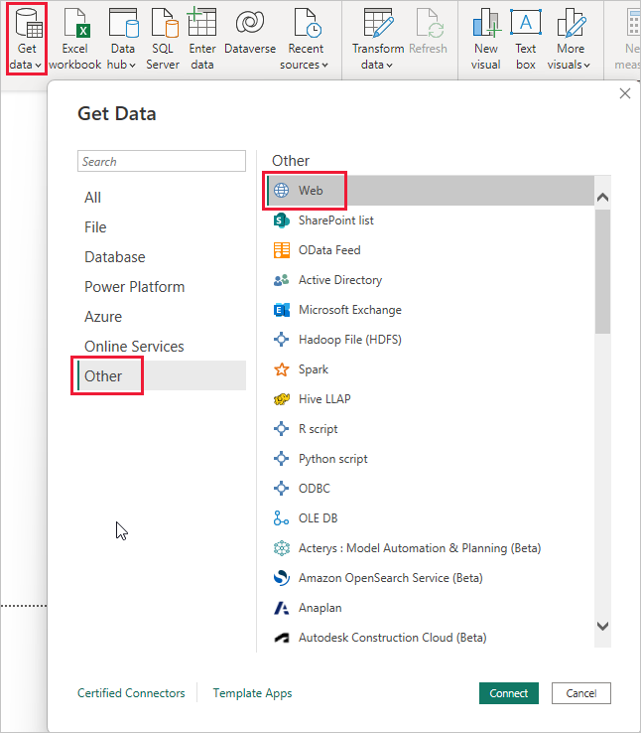

## Example of connecting to data

For this example, we'll connect to a **Web** data source.

Select **Get data** > **Other** > **Web**. In **From Web**, enter the address.

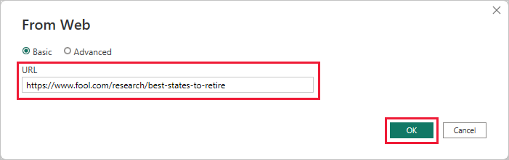

When you select OK, the Query functionality of Power BI Desktop goes to work. Power BI Desktop contacts the Web resource, and the Navigator window returns the results of what it found on that Web page. In this case, it found a table. We're interested in that table, so we select it from the list. The Navigator window displays a preview.

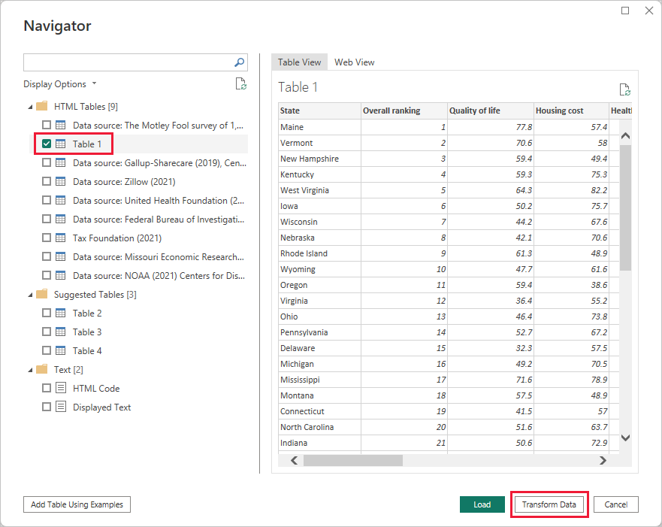

At this point, you can edit the query before loading the table, by selecting Transform Data from the bottom of the window, or just load the table.

Select Transform Data to load the table and launch Power Query Editor. The Query Settings pane is displayed. If it's not, select View from the ribbon, then choose Query Settings to display the Query Settings pane. Here’s what the editor looks like.

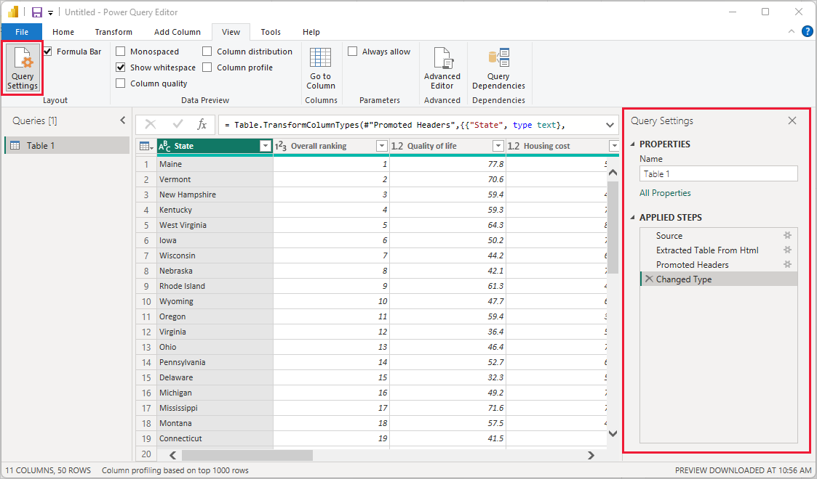

All those scores are text rather than numbers, and we need them to be numbers. No problem. Just right-click the column header, and select Change Type > Whole Number to change them. To choose more than one column, first select a column then choose Shift, select other adjacent columns, and then right-click a column header to change all selected columns. Use Ctrl to choose columns that aren't adjacent.

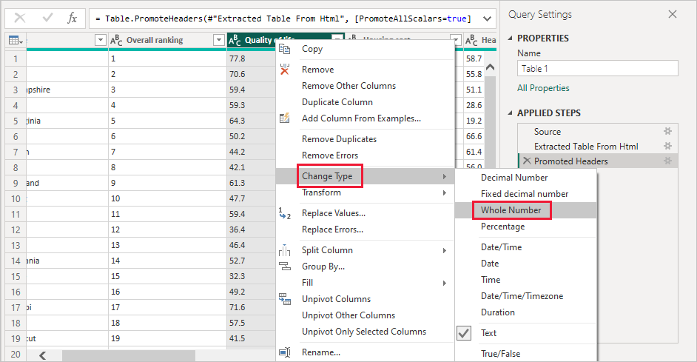

In Query Settings, the APPLIED STEPS reflect any changes that were made. As you make more changes to the data, Power Query Editor records those changes in the APPLIED STEPS section, which you can adjust, revisit, rearrange, or delete as necessary.

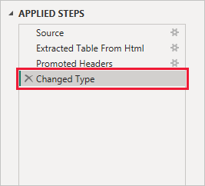

Other changes to the table can still be made after it's loaded, but for now these changes are enough. When you're done, select Close & Apply from the Home ribbon, and Power BI Desktop applies the changes and closes Power Query Editor.

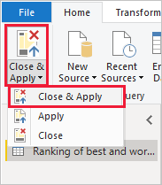

1. How to import Local files in Power BI? Mention the Steps.

**Ans:**  If you save your workbook file to a drive on your computer or another location in your organization,

you can import your file into Power BI. Your file actually remains on the source drive, so Power BI doesn't

really import the file. Power BI actually creates a new dataset in your site and loads your data and in some

cases your data model into the dataset. Any reports in your file appear in your Power BI site under Reports.

Steps:

1. In Power BI, click Get Data in the lower left screen.
2. Under Import or Connect to Data > Files, click Get.
3. Click Local File.
4. Choose which file to upload and click Open.
5. Click Upload under Upload your Excel file to Power BI.
6. The message “Your file has been uploaded” should appear.
7. In Power BI visualization, what are Reading View and Editing view?

**Ans:** There are two modes for interacting with reports in the Power BI service: Editing view and Reading view. If you are a business user, then you are more likely to use Reading view to consume reports created by others. Editing view is used by report designers, who create the reports and share them with you. Reading view is your way to explore and interact with reports created by colleagues.

Most reports open in Reading view. To switch from Reading view to Editing view, select Edit from the action bar. If Edit is grayed out, that means that you don't have permissions to edit the report.

To switch back to Reading view, select Reading view from the action bar.

Even in Reading view, the content isn't static. You can dig in, looking for trends, insights, and other business intelligence. Slice and dice the content, and even ask it questions using your own words. Or, sit back and let your data discover interesting insights for us; send us alerts when data changes, and email reports to us on a schedule we set. All our data, any time, in the cloud or on-premises, from any device.